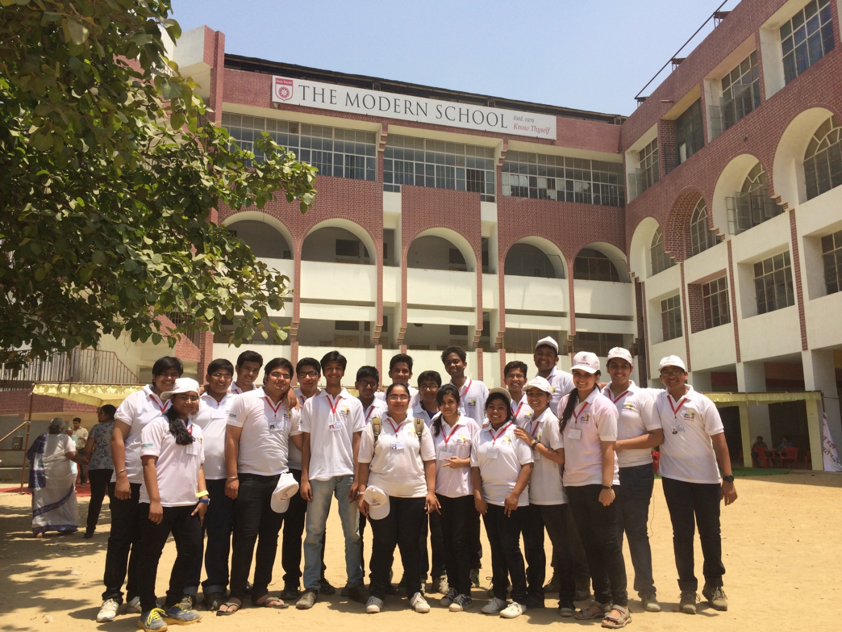
With the Political surge still roaring in the entire nation, the time of the elections did cast the most intensive sunlight in all areas of the country. On 30th of April, 2014, the city of Nawabs, Lucknow, among many other cities was under the same sunlight, when the people here travelled to polling booths across the city to vote for their favorite leaders.
Among these polling booths were 29 schools that were chosen to facilitate the voting process as special centers for voting. The Modern School was one of these special polling stations.
On the day of election, The Modern School provided various facilities to the voters who were supposed to visit the premises to cast their votes. Amid these facilities, due to extreme weather conditions, Cold Drinking Water and Waiting Area Tents for Voters.
The students took care of the elderly voters by providing them with Wheel Chairs and accompanied them throughout the voting session. For keeping them occupied with information while they waited, LCD Screens were installed in the waiting area for the voters to see the entire process of voting going inside the booth. For voters, there were appropriate training sessions to guide them through the process of voting once they enter the polling booth.
A lot of goodies were arranged for the students and the staff that was on duty making sure the voters faced no difficulty in their time at the premises of the polling station. Our students grabbed Caps and

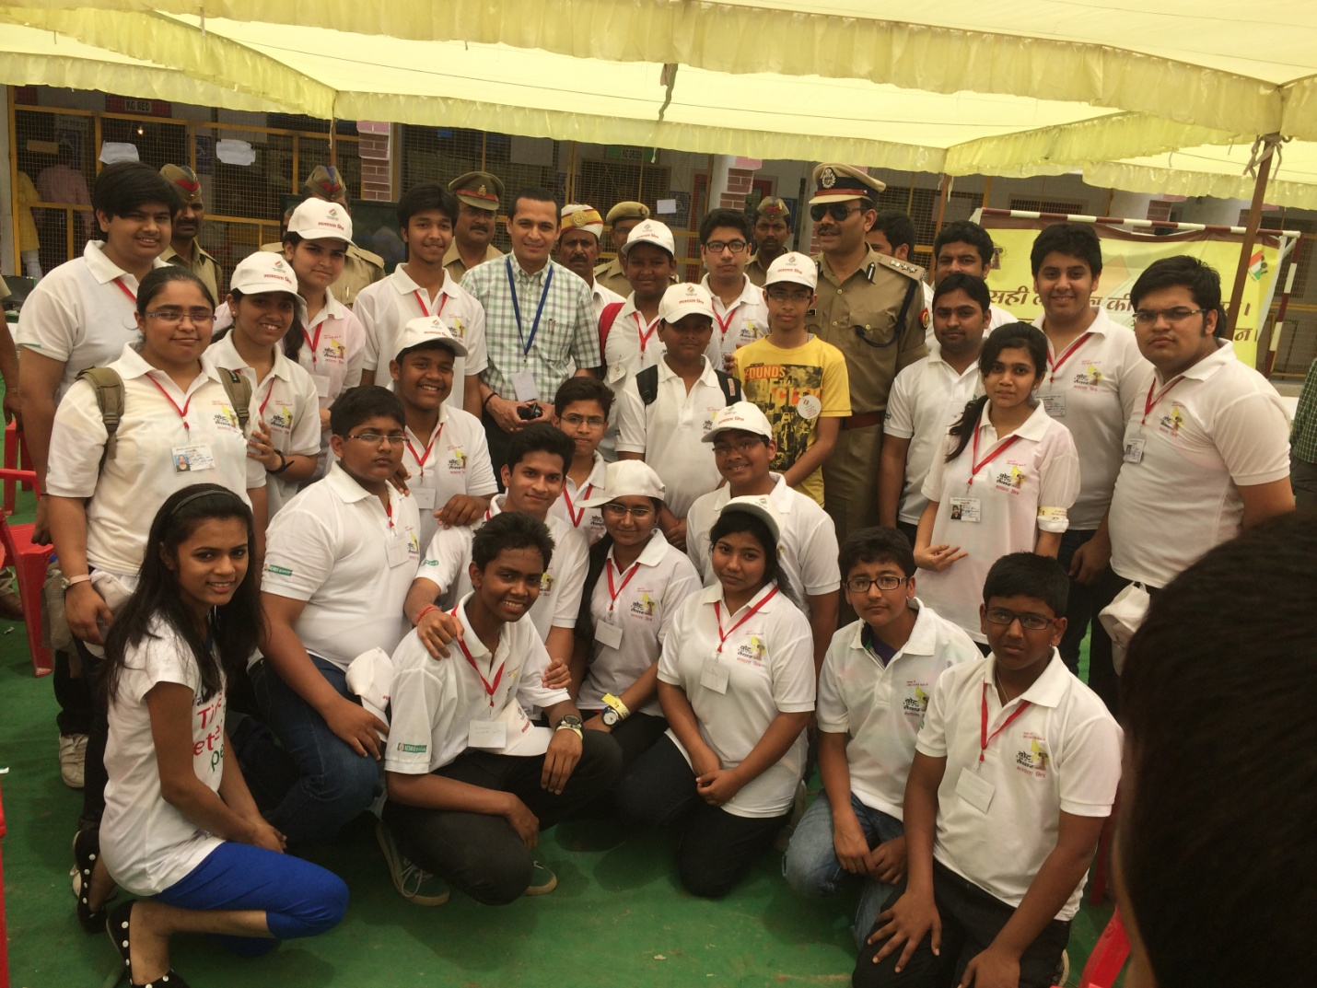
t-shirts along with Free Cold Drinks and Wafers while they tended to the responsibility of easing up the most important process of a democracy.
While the students got more freebies to warm up to the voting process, they were presented with Free Refreshments, Lunchboxes, Cold Drinks and Packaged Drinking Water along with the on-duty staff which also received caps as a token of thanks.
As The Modern School boldly thrives towards imparting Practical Knowledge of Living Life to its students, the greatest Democratic Festival was celebrated here with utter happiness and joy. The students of the school participated in huge numbers as volunteers for assisting the staff on the day of voting, expressing their knowledge about importance of elections. They have shown all signs of becoming responsible citizens of the country, once they are of age to play the part.
The spark of the young mind is only possible with appropriate driving forces around it. These forces influence the child greatly and resemble his/her actions in the future.

